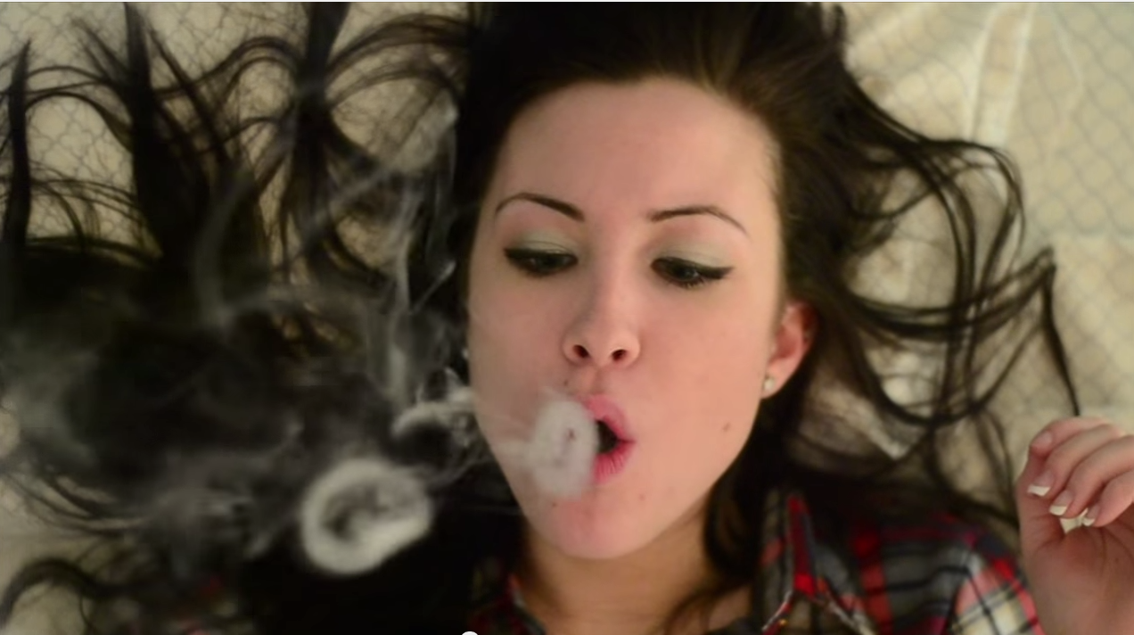

**White Teeth Teens- Lorde Music Video**

March 21, 2014

This video, a cover of the song White Teeth Teens by Lorde, was entered into the Hendrick Hudson Film Festival and after the long 3 months of planning, seeking locations, shooting, and editing, my friends and I ended up on the podium as 1st runners up.

Roles: Actress, producer, cinematographer, editor

<https://www.youtube.com/watch?v=detkJlHa8gQ>

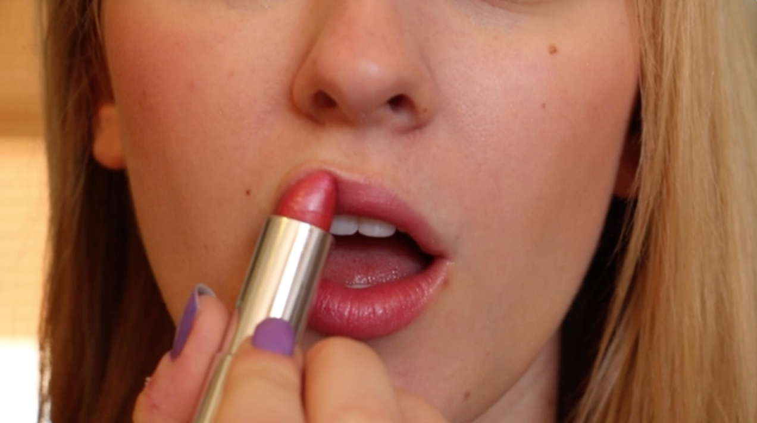

**Body Image Public Service Announcement**

April 15, 2015

A partner and I got creative with a Women’s Studies assignment to create a Public Service Announcement on an issue that impacts the lives of women in the United States.

Roles: Writer, producer, cinematographer, director, editir

<https://www.youtube.com/watch?v=3OeKUGgTeIo>

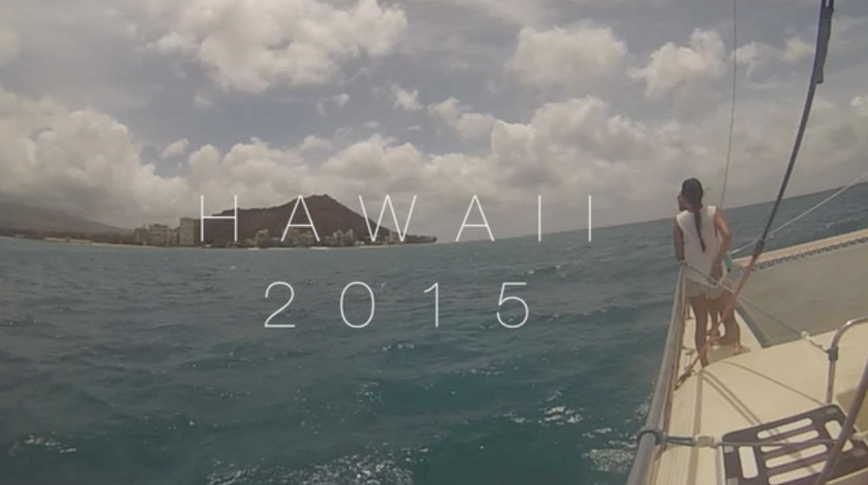

**Hawaii 2015- Go Pro Video**

May 17, 2015

After receiving a Go Pro as a gift prior to my trip to Oahu, Hawaii, I was able to capture an array of footage of my adventures! After editing the videos together, I set them to the catchy tune of Island in the Sun by Weezer.

Roles: Director, cinematographer, editor

<https://www.youtube.com/watch?v=iVwEjdVBqi8>

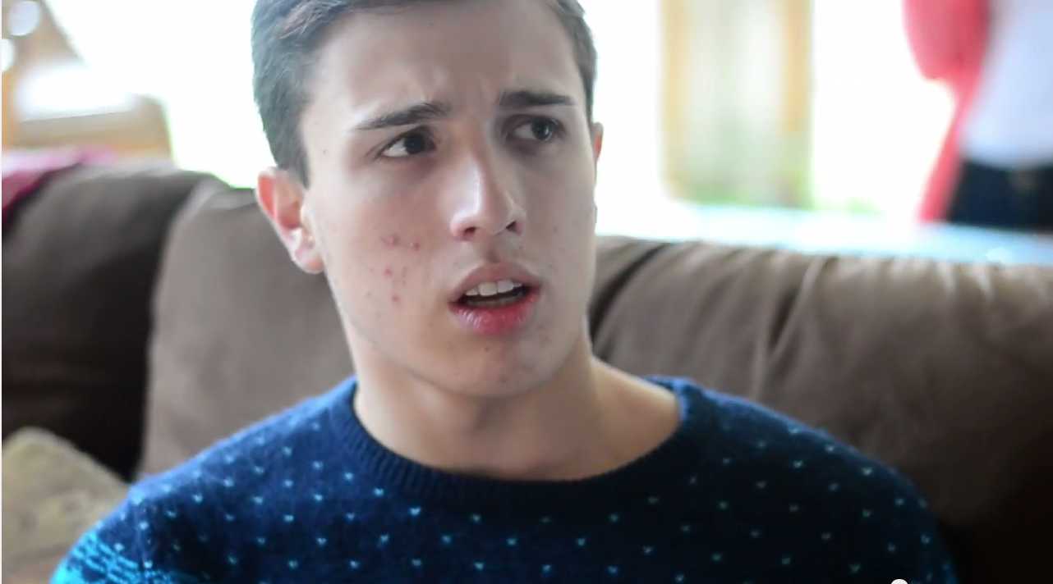

**Key To His Heart**

January 24, 2014

My high school (Old Bridge High School) hosted a film festival where the contestants received a specific character, prop, and line of dialogue, which all had to be included in the piece submitted. My group won 1st place for the festival for this creepy, yet comedic video, which I not only helped produce, but also starred in!

Roles: Actor, cinematographer, producer, writer, editor

<https://www.youtube.com/watch?v=zIM3-mtsn5c>

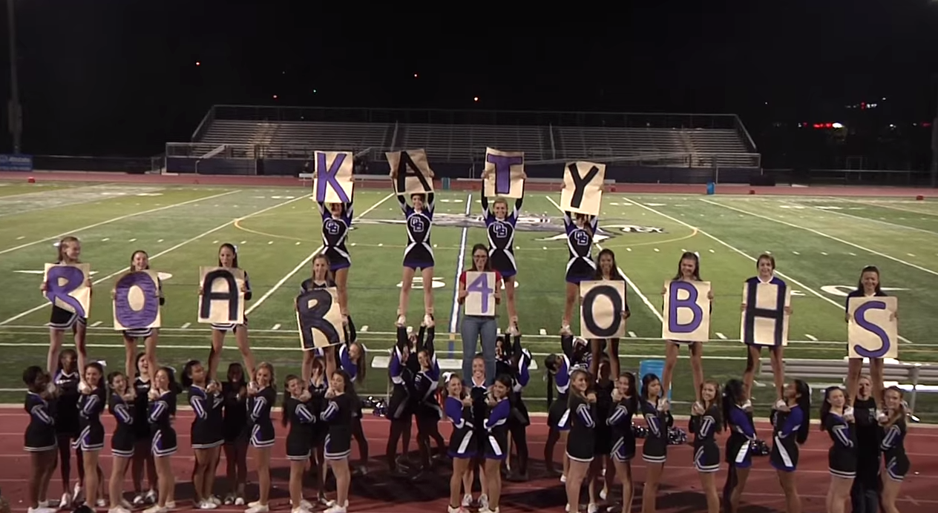

**Katy Roar 4 OBHS**

October 1, 2013

The famous singer, Katy Perry, gave high schools around the country a challenge: the school who could create the best video for her hit song “Roar” would have her perform live at a school event. Old Bridge High School didn’t win the challenge, but Katy Perry sure heard us roar!

Roles: Cinematographer, writer, producer, editor

[**https://www.youtube.com/watch?v=zuzFsEO-NnE**](https://www.youtube.com/watch?v=zuzFsEO-NnE)

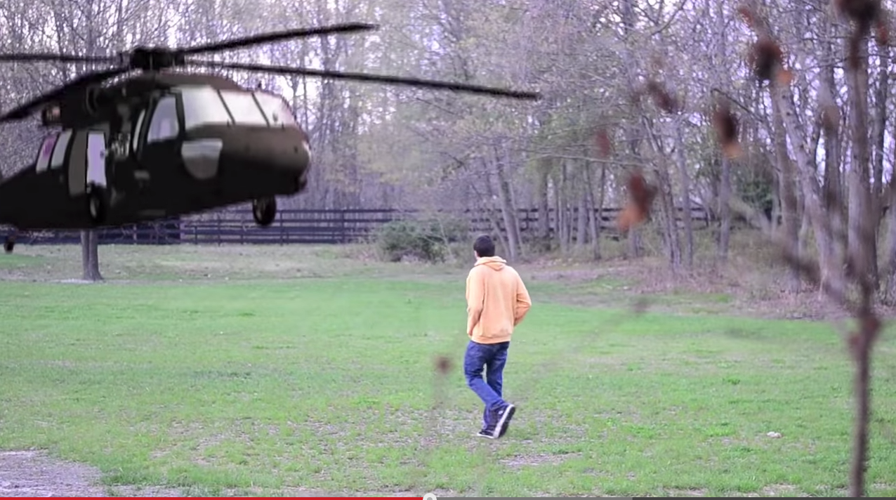

**Asking Erica to Prom!**

May 24, 2014

When someone wanted a creative way to ask a friend of mine to prom, we couldn’t help but make her this cheesy video.

Roles: Editor

<https://www.youtube.com/watch?v=ezmH6WjycbU>

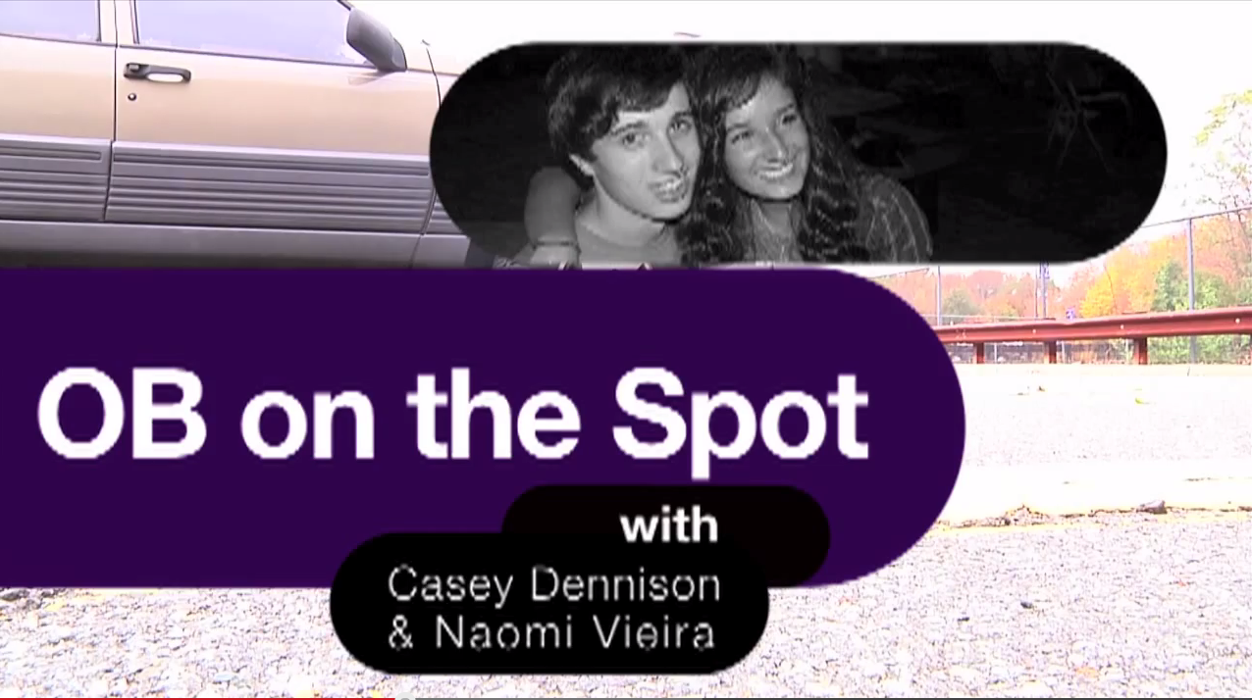

**OB on the Spot- “Knightly Wrap Up” Segment**

September 2013-June 2014

Not only did I help produce Old Bridge High School’s weekly news show titled “The Knightly Wrap Up,” I also contributed a segment with a friend where we would interview OBHS students at local businesses. Check out a few of our segments here:

Roles: Talent, producer, cinematographer, editor

<https://www.youtube.com/watch?v=Ib2G8mEeS-o>

<https://www.youtube.com/watch?v=5I2GAvukiK4>

<https://www.youtube.com/watch?v=G9mkaqjjJUg>

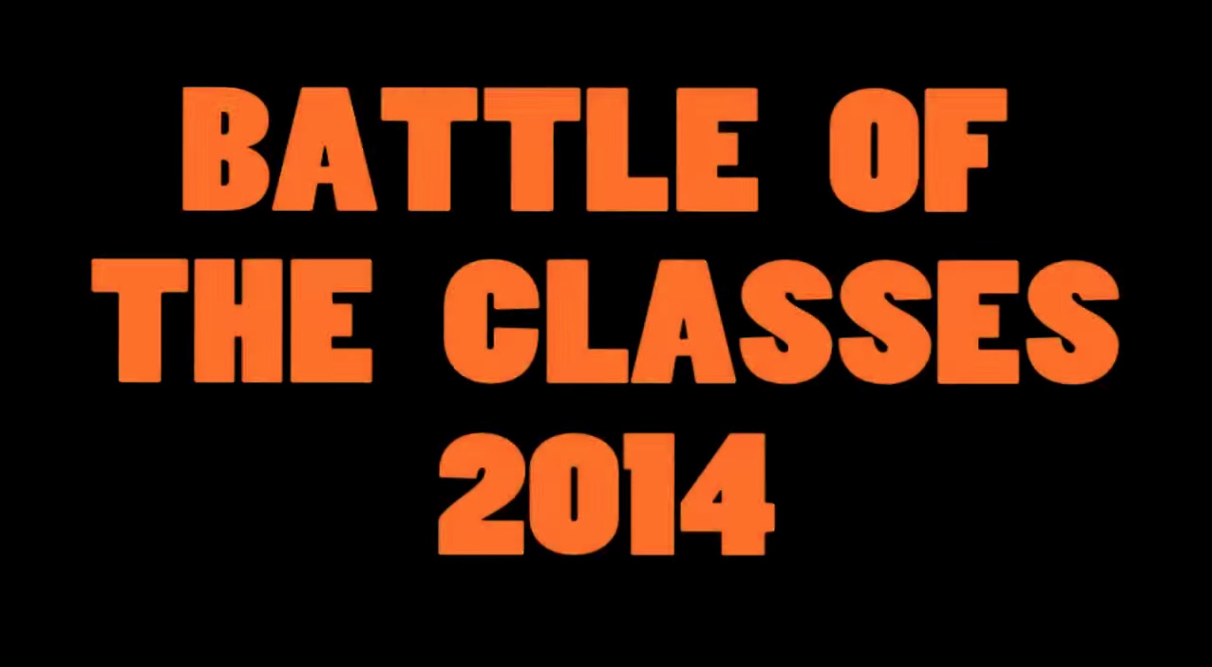

**“Battle of the Classes” Video**

April 21, 2014

Every year, Old Bridge High School hosts a pep rally called “Battle of the Classes” which is supposed to begin with an iconic video. My senior year, I was chosen to make it, and after weeks of filming and editing it was great to see my work on the screen before the event!

Roles: Cinematographer, producer, editor

<https://www.youtube.com/watch?v=kMSn5YjgyZs>

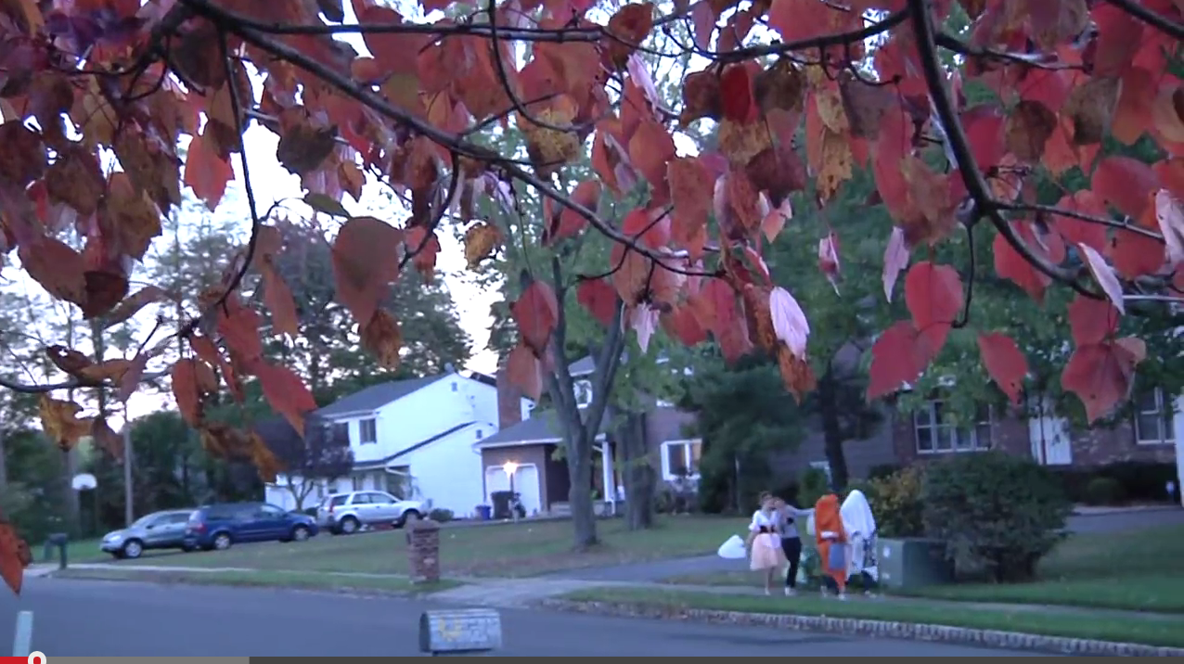

**Cursed**

January 17, 2013

It was my first time working with a green screen on this Halloween themed production. It took weeks to edit the green screen to create the space scene that these trick-or-treaters get sucked into after eating magical candy. Not only was there experimentation with a green screen, but I also tried to mimic different film genres such as horror and silent film.

Roles: Cinematographer, actress, editor, producer

<https://www.youtube.com/watch?v=UqKGJLP71fM>